# Introduction

The Playing Cards Holder is an assistive device for holding playing cards. This fully 3D printed device aims to assist those with limited dexterity by giving them an alternate means for holding their playing cards. Users will be able to place their cards into the holder to have them displayed during game play.

# Research

## Handheld Holders

There are a variety of commercially available card holders that assist in holding cards within a person’s hand. This type sandwiches cards between its two halves and holds them secure with friction. They cost approximately $20 and are targeted to aid users with arthritis.

[Brybelly Triangle Shaped Hands-Free Playing Card Holder : Amazon.ca: Toys & Games](https://www.amazon.ca/Brybelly-Triangle-Shaped-Hands-Free-Playing/dp/B00DQRDK6K/ref=asc_df_B00DQRDK6K?tag=bingshopdesk-20&linkCode=df0&hvadid=80470598951881&hvnetw=o&hvqmt=e&hvbmt=be&hvdev=c&hvlocint=&hvlocphy=&hvtargid=pla-4584070143706352&psc=1)

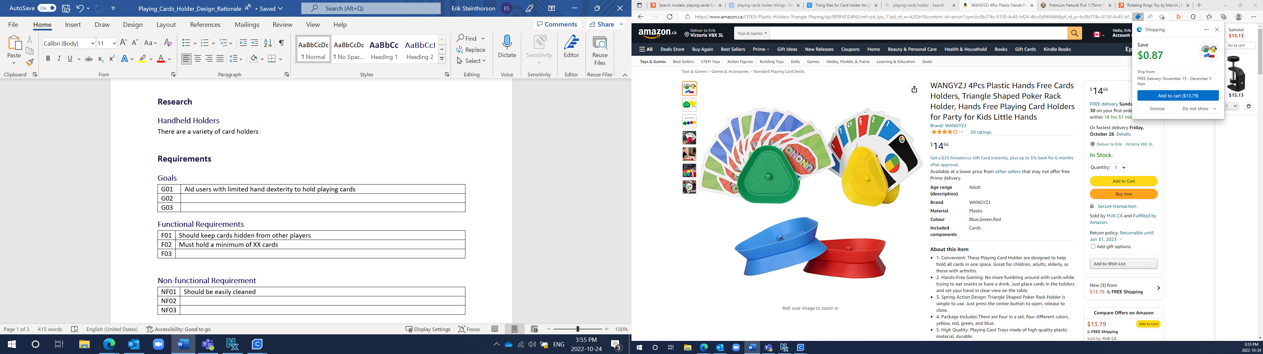

## Tabletop Holders

The other common type is the tabletop holder. This allows cards to be held hands free but requires a table or surface to be placed on. They cost around $25 for a set and are targeted to aid users with arthritis.

[Playing Card Holder Tray Great for Seniors & Kids Hands Free Playing Card Holders (Set of 4), Standard Playing Card Decks - Amazon Canada](https://www.amazon.ca/Playing-Holder-Great-Seniors-Holders/dp/B07BHRRJ9K/ref=asc_df_B07BHRRJ9K?tag=bingshopdesk-20&linkCode=df0&hvadid=80470598951881&hvnetw=o&hvqmt=e&hvbmt=be&hvdev=c&hvlocint=&hvlocphy=&hvtargid=pla-4584070143706321&psc=1)

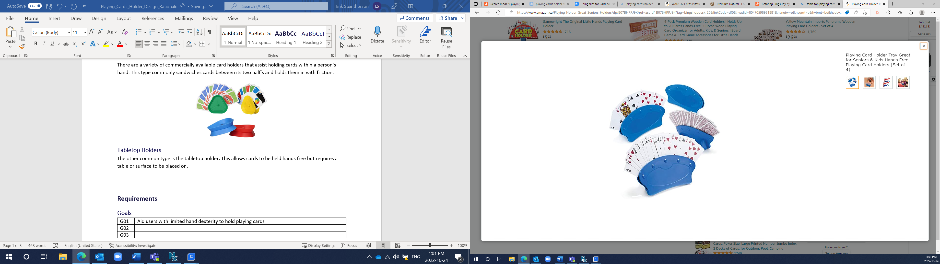

# Requirements

## Goals

|  |  |
| --- | --- |
| G01 | Make it easier for users with limited dexterity hold playing cards |
| G02 | Assist recreation and leisure |

## Functional Requirements

|  |  |
| --- | --- |
| F01 | Cards should be kept hidden from other players |
| F02 | Cards should still be accessible when holder is full |
| F03 | Holder must be stable enough to not tip over |
| F04 | Must be easy to place and take cards from holder |
|  | (How many cards should it hold?) |

## Non-functional Requirement

|  |  |
| --- | --- |
| NF01 | Should be easy to clean |
| NF02 | Capable of holding various sized cards |

## Constraints

|  |  |
| --- | --- |
| C01 | Must be printable on standard sized 3D printers |

# Existing Designs

Feedback was gathered from users with various degrees of hand dexterity challenges.

## Multi-Tier Card Holder - User Test 1

This design allows for four rows of cards to be held with a slight curve. This offers enough room to hold an entire standard deck of cards: one full suit (13) per row. However, it did not encompass the required user accessibility. Users found it too difficult to access and place cards among the multiple crowded rows. Singles tiered card holders will be the ideal approach.

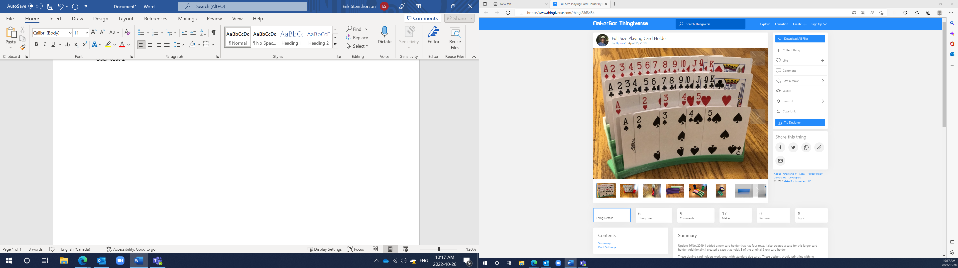

Source: [Full Size Playing Card Holder by Djones1t - Thingiverse](https://www.thingiverse.com/thing:2863434)

Licence: [Creative Commons — Attribution 4.0 International — CC BY 4.0](https://creativecommons.org/licenses/by/4.0/legalcode)

## Single Tier Card Holder - User Test 2

This single layer card holder curves to angle the cards towards the users and holds the cards in a tilted back position. After testing, users found the single layer to be ideal for their accessible needs but found this design too small. The holder became too crowded when loaded up with cards.

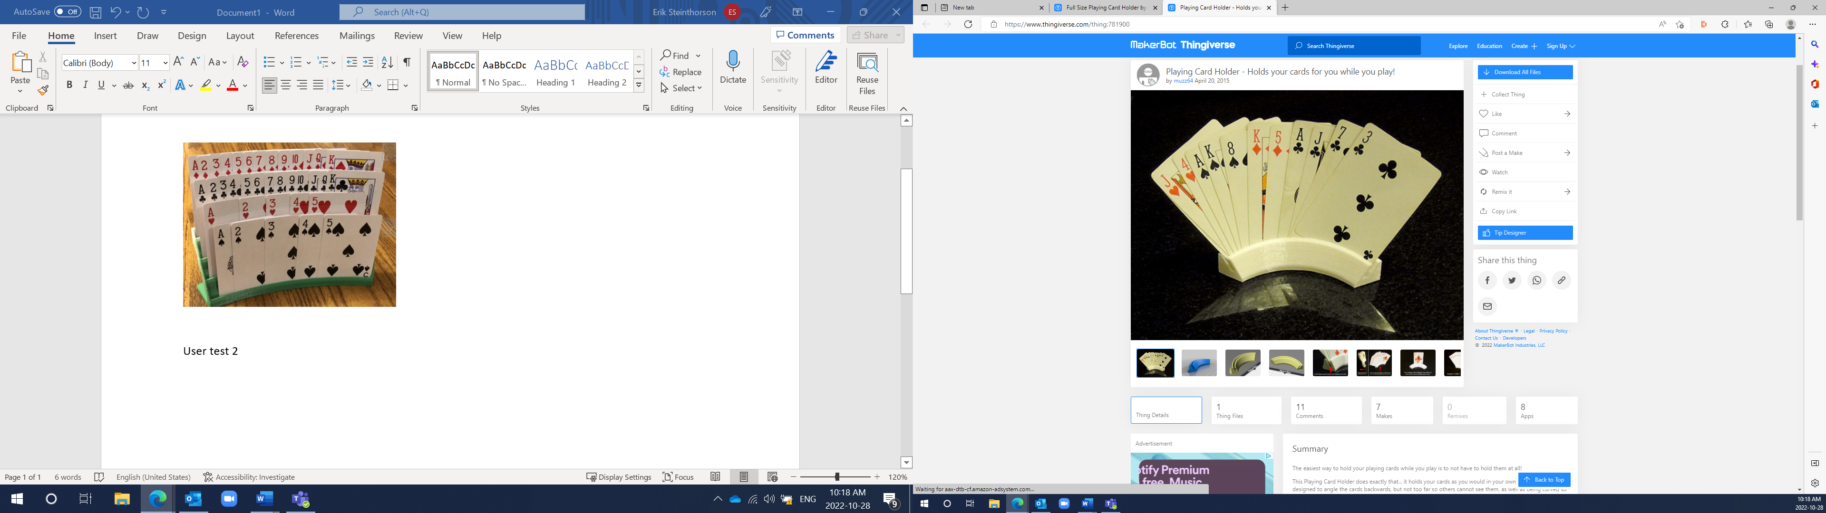

Source: [Playing Card Holder - Holds your cards for you while you play! by muzz64 - Thingiverse](https://www.thingiverse.com/thing:781900)

Licence: [Creative Commons — Attribution 4.0 International — CC BY 4.0](https://creativecommons.org/licenses/by/4.0/legalcode)

# Other Design Considerations

Holder 1 – Extra Wide Playing Card Holder

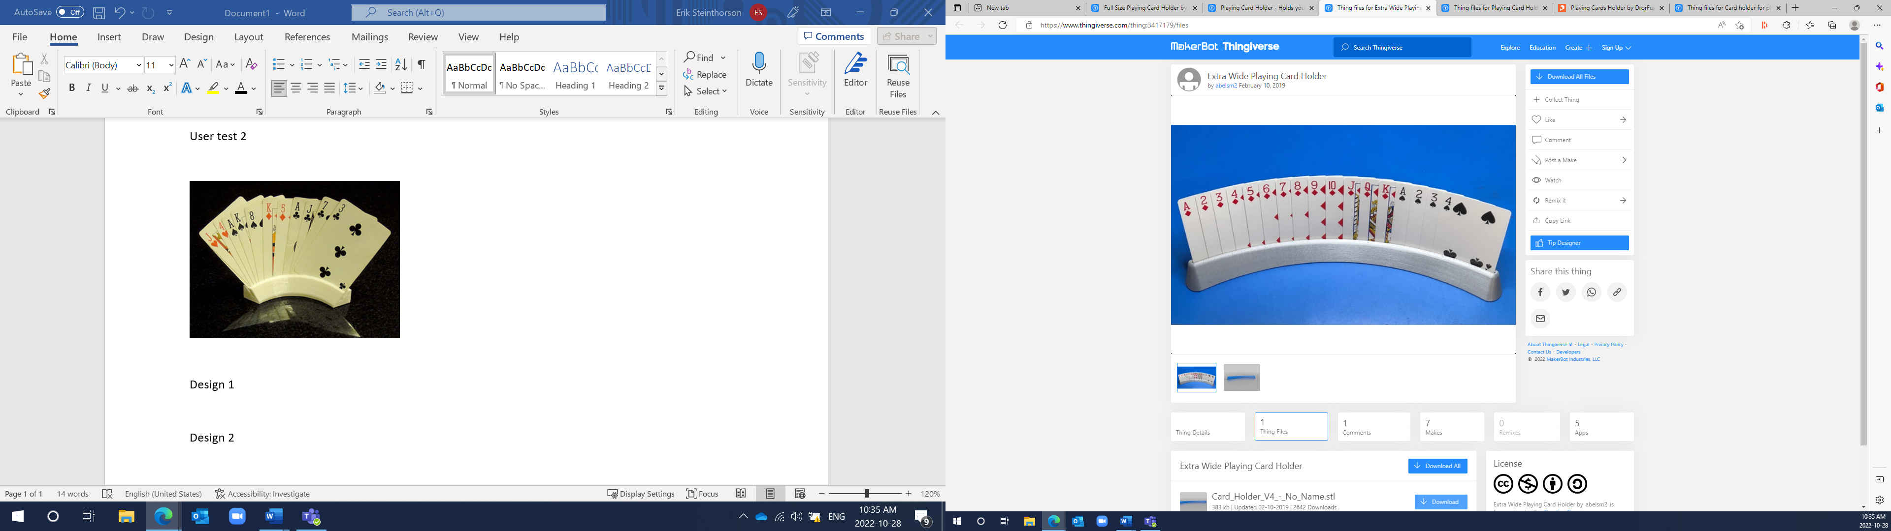

* Designed to be the maximum size for the Prusa MK3
* Must be scaled to 85% to fit on Ender3 bed
* Functionality decreased due to scaling: card slot quite narrow
* 5h 36m print time
* Single tier
* Curved slightly towards user
* Holds cards slightly tilted back
* Holds 4 non-over lapping cards and approximately a maximum of 18 spaced closely

Source: [Thing files for Extra Wide Playing Card Holder by abelsm2 - Thingiverse](https://www.thingiverse.com/thing:3417179/files)

Licence: [Creative Commons](https://creativecommons.org/licenses/by-nc-sa/4.0/legalcode)

## Holder 2 – Playing Card Holder

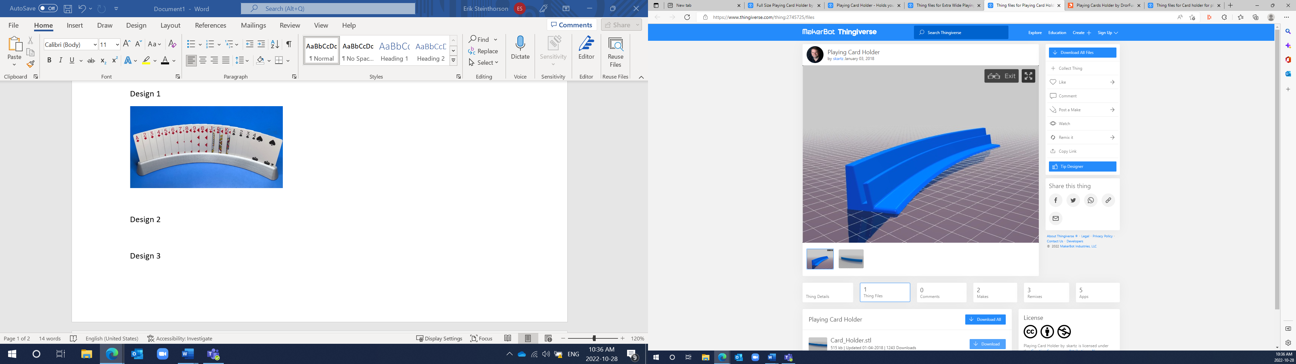

* Must be scaled to 90% to fit on Ender3 bed
* Functionally still works great while scaled
* 5h 41m print time
* Single tier
* Curved slightly towards user
* Holds cards slightly tilted back
* Wider base for stability
* Holds 4 non-over lapping cards and approximately a maximum of 20 spaced closely
* Interesting design with the rear wall being taller than the from allowing cards to be ‘banked’ in

Notes: This would be a good design to get user feedback on. It has the highest card capacity of the single tier holders considered. Its wide base makes it very stable and almost hard to tip over. It would also be interesting to see if users find this cross section more accessible.

## Source: [Thing files for Playing Card Holder by skartz - Thingiverse](https://www.thingiverse.com/thing:2745725/files)

Licence: [Creative Commons](https://creativecommons.org/licenses/by-nc-sa/4.0/legalcode)

## Holder 3 – Playing Cards Holder

* Sized perfectly for Prusa Mini (will fit on all maker printers)
* 4h 17m print time
* Single tier
* Slight curve
* Holds cards straight up (no lean)
* Circular feet for stability
* Holds 3 non-over lapping cards and approximately a maximum of 14 spaced closely

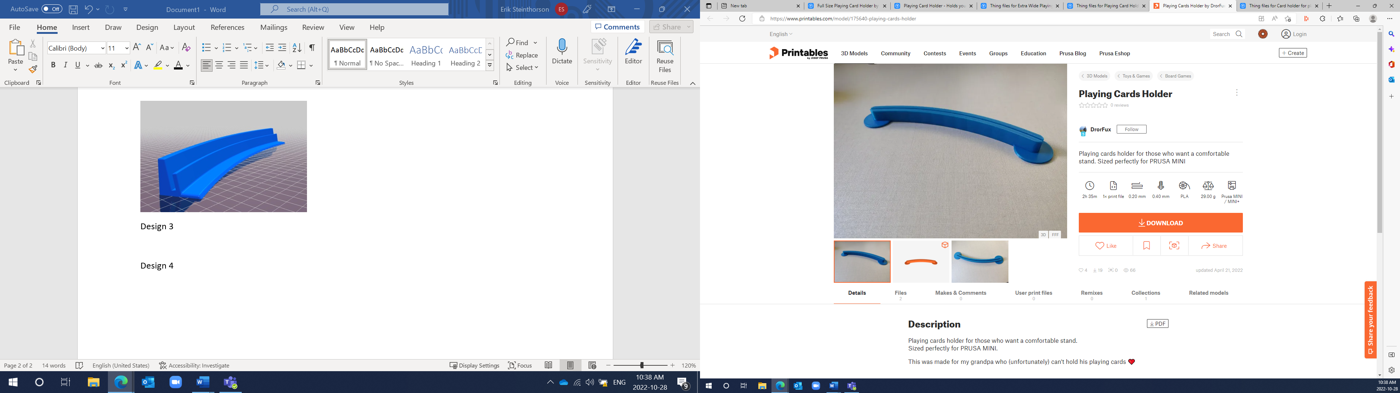

Notes: User feedback on this design could be beneficial. Its print size is convenient for maker printers and the design of its base makes it very stable. More information on whether this meets user accessibility would be needed.

## Source: [Playing Cards Holder by DrorFux | Download free STL model | Printables.com](https://www.printables.com/model/175640-playing-cards-holder)

Licence: [Creative Commons](https://creativecommons.org/licenses/by-nc-sa/4.0/legalcode)

## Holder 4 – Connectable Playing Cards Holder

## A interconnectable 3D printed cards holder displaying various cards.

* Modular design allowing for multiple units to connect together
* Individual components will fit on any printer
* 1h 48m print time
* No curve
* Holds cards slightly tilted back
* Similar cross section as holder 2
* Smaller size: 12cm long and 2 cm wide
* Tab to attach multiple together is quite weak

Notes: Due to its narrow base and lack of curve, this design was quite unstable. However, it was the only modular single tier card holder I could find. If a custom holder is to be designed, this could be a good foundation to expand from.

Source: [Thing files for Card holder for playing cards by elliotsfar - Thingiverse](https://www.thingiverse.com/thing:4248953/files)

Licence: [Creative Commons](https://creativecommons.org/licenses/by-nc-sa/4.0/legalcode)

## Existing Design Comparison

|  |  |  |  |  |  |
| --- | --- | --- | --- | --- | --- |
|  | **Design 1** | **Design 2** | **Design 3** | **Design 4** | **User Test 1** |
| Style (handheld / desk) | Desk | Desk | Desk | Desk | Desk |
| Size [cm] | ~27 x 2.2 x 2 | ~25 x 2.2 x 2.7 | ~21 x 1.7 x 1.1 | ~12 x 1.6 x 2 | ~20.5 x 7.5 x 4 |
| Print Time | 5h 36m | 5h 41m | 4h 17m | 1h 48m | 10h 26m |
| Cost | ~$1.00 | ~$1.05 | ~$0.85 | ~$0.33 | 64g |
| License | [Creative Commons](https://creativecommons.org/licenses/by-nc-sa/4.0/legalcode) | [Creative Commons](https://creativecommons.org/licenses/by-nc-sa/4.0/legalcode) | [Creative Commons](https://creativecommons.org/licenses/by-nc-sa/4.0/legalcode) | [Creative Commons](https://creativecommons.org/licenses/by-nc-sa/4.0/legalcode) | [Creative Commons](https://creativecommons.org/licenses/by-nc-sa/4.0/legalcode) |

# Conceptual Design

## Part Separation / Connection

Dovetail

# Detailed Design

After receiving user feedback, the optimal design for the paying cards holder is either User Test 1 or Holder 2. The first is a multi-tier holder capable of holding many cards. It has approximate dimensions of 20.5 x 7.5 x 4 cm. The initial impression of this holder was that it may become too difficult to use once full of cards. However, after further testing from users, the fact that it can hold over twice the number of cards makes it a better option when used below max capacity.

The second holder is the largest single tier holder considered but may still be limiting based on the maximum number of cards it can hold. It has approximate dimensions of 25 x 2.2 x 2.7 cm. This is a good option based on its wide base and cross section design.

Both designs are maker friendly, sturdy, and accessible. Therefore, both designs will be released as separate devices.